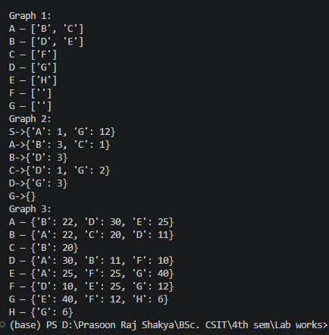

5.1 | 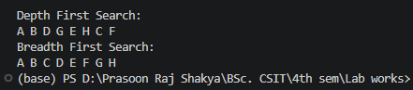
5.2 | 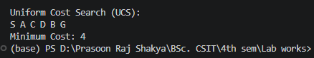
5.3 | 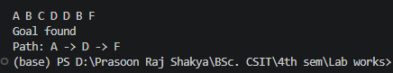

6.1 | 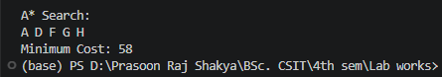
6.2 | 

